CSC 403 ICE 3

1. Show the result of put(22 ) on each graph below.

20

40

16

5

8

42

32

26

24

20

40

16

5

8

42

32

24

26

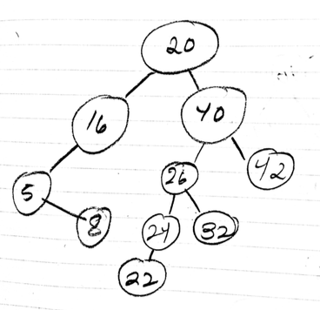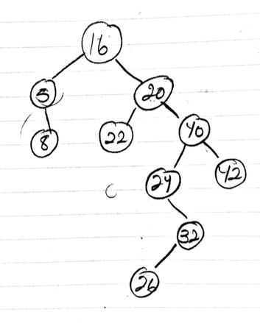

1. Determine the following for the graph on the left.

Rank( 22 ) 4 Floor(22) 20

1. Using the Hibbard algorithm, show the resulting BST for the deletions

Delete(16) left tree , Delete(40) right tree

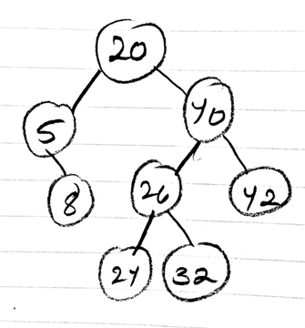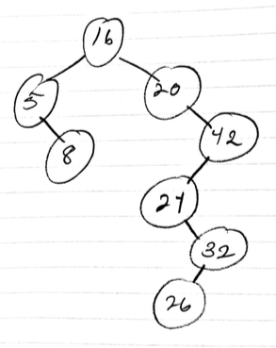

20

40

16

5

8

42

32

26

24

20

40

16

5

8

42

32

24

26

1. The recursive versions of put and delete both modify the BST and use a helper function. Conceptually, what do the helper functions return? { we discussed this several times in class}

The helper functions return a Node object that conceptually represents the entire left/right subtree post-put or post-delete.